# **SOFTAWRE DESIGN AND ARCHITECTURE**

# **BANK MANAGEMENT SYSTEM**

# **DIAGRAMS**

**USE CASE DIAGRAM**

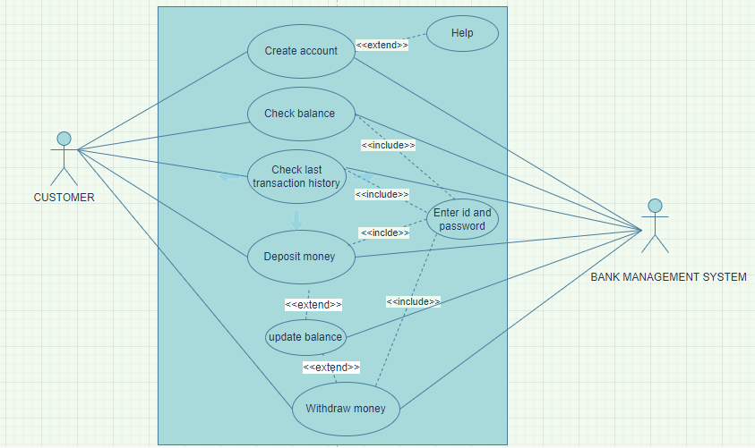

## **ACTIVITY DIAGRAM**

## 

ACTIVITY DIAGRAM FOR VIEW TRANSCATION HISTORY

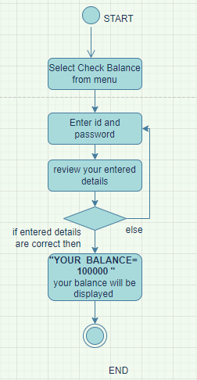

ACTIVITY DIAGRAM FOR CHECK BALANCE

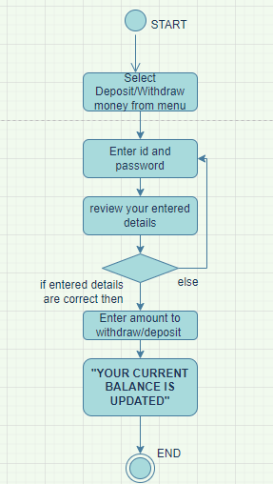

**ACTIVITY DIAGRAM FOR DEPOSIT/WITHDRAW MONEY**

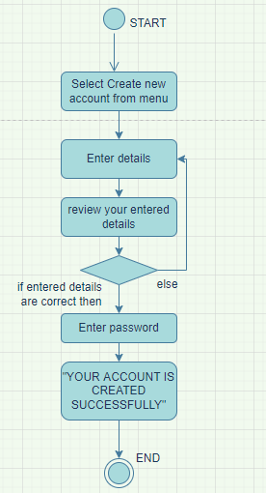

**ACTIVITY DIAGRAM FOR CREATE ACCOUNT**

# **CLASS DIAGRAM**

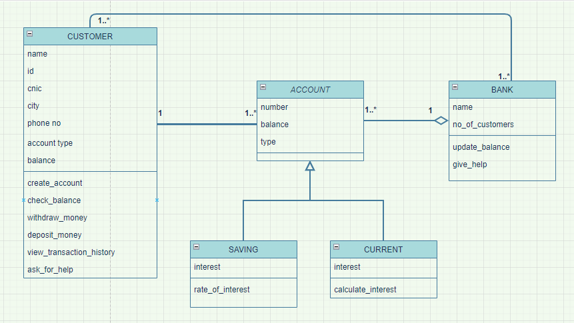

# **SEQUENCE DIAGRAM**



